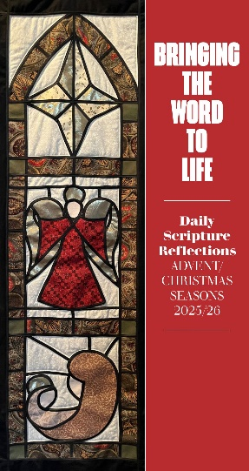
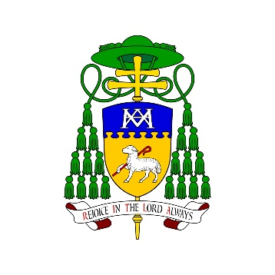
ORDER FORM

Please send the completed form to
info@wn.catholic.org.nz

Please note there is a minimum order of 10 books per parish.
Cost per book: $5
Shipping: $6.50 per order (regardless of size)
----------------------------------------------------------------------------------
Name of parish:
______________________________________________________________________

Number of books to order (please circle):

10 20 30

For orders more than 30, please write number: _________

Postal address for books to be sent to:
_________________________________________________________________________________
_________________________________________________________________________________

Contact person at parish:
__________________________________
Contact details (email and phone number):
____________________________ (Email) ____________________________ (Phone No.)

For questions, please email info@wn.catholic.org.nz.

